SWT 22022-Practical for Internet Application Development
Department of Information and Communication Technology
Faculty of Technology
Lab sheet :09
Reg. Number: SEU/IS/20/ICT/084
Academic Year :2020/2021
Date: 2024.07.11
Practical No :09

Title: PHP, MySQL and JavaScript - II
Aims:
- Implement CRUD operations with PHP, MySQL, and JavaScript
Tasks:
- Implement CRUD operations in PHP
- Use fetch() to handle frontend requests

Activities :

Create a new table named “expenses” within “expense_tracker” database

Implement CRUD operation in PHP

add_expense.php

<?php
require_once '../database/Expense.php';
require_once '../database/Database.php';
$database = new Database("localhost", "root", "", "expense_tracker");
$db = $database->getConnection();
$expense = new Expense($db);
$data = json_decode(file_get_contents("php://input"));
$expense->setDescription($data->description);
$expense->setAmount($data->amount);
if ($expense->create()) {
echo json_encode(["message" => "Expense added."]);
} else {
echo json_encode(["message" => "Unable to add expense."]);
}
?>

view_expenses.php

<?php
require_once '../database/Expense.php';
require_once '../database/Database.php';
$database = new Database("localhost", "root", "", "expense_tracker");
$db = $database->getConnection();
$expense = new Expense($db);
$expenses = $expense->getAllExpenses();
$num = count($expenses);
if ($num > 0) {
$expenses_arr = array();
$expenses_arr["records"] = $expenses;
echo json_encode($expenses_arr);
} else {
echo json_encode(["records" => []]);
}
?>

edit_expense.php

<?php
require_once '../database/Expense.php';
require_once '../database/Database.php';
$database = new Database("localhost", "root", "", "expense_tracker");
$db = $database->getConnection();
$expense = new Expense($db);
$data = json_decode(file_get_contents("php://input"));
$expense->setId($data->id);
$expense->setDescription($data->description);
$expense->setAmount($data->amount);
if ($expense->update()) {
echo json_encode(["message" => "Expense updated."]);
} else {
echo json_encode(["message" => "Unable to update expense."]);
}
?>

delete_expense.php

<?php
require_once '../database/Expense.php';
require_once '../database/Database.php';
$database = new Database("localhost", "root", "", "expense_tracker");
$db = $database->getConnection();
$expense = new Expense($db);
$data = json_decode(file_get_contents("php://input"));
$expense->setId($data->id);
if ($expense->delete()) {
echo json_encode(["message" => "Expense deleted."]);
} else {
echo json_encode(["message" => "Unable to delete expense."]);
}
?>

3. Use fetch() to handle frontend requests

I. loadEpenses()

async function loadExpenses() {
try {
const response = await fetch('php/view_expenses.php');
const data = await response.json();
const expenseList =document.getElementById('expenseList');
expenseList.innerHTML = '';
if (Array.isArray(data.records) && data.records.length >0) {
data.records.forEach(expense => {const item = document.createElement('li');
item.innerHTML = `${expense.created_at}:
${expense.description} - $${expense.amount}
<button onclick="editExpense(${expense.id},'${expense.description}', ${expense.amount},'${expense.created_at}')">Edit</button>
<button onclick="deleteExpense(${expense.id})">Delete</button>`;
expenseList.appendChild(item);
});
} else {const item = document.createElement('li');
item.innerHTML = 'No expenses found.';
expenseList.appendChild(item);
}
} catch (error) {
console.error('Error loading expenses:', error);
}
}

II. addExpense()

async function addExpense() {
const description =
document.getElementById('description').value;
const amount = document.getElementById('amount').value;
const response = await fetch('php/add_expense.php', {
method: 'POST',
body: JSON.stringify({ description, amount }),
headers: { 'Content-Type': 'application/json' }
});
const result = await response.json();
alert(result.message);
loadExpenses();
}

III. updateExpense()

async function updateExpense() {
const id = document.getElementById('expenseId').value;
const description =document.getElementById('editDescription').value;
const amount = document.getElementById('editAmount').value;
const response = await fetch('php/edit_expense.php', {
method: 'POST',
body: JSON.stringify({ id, description, amount }),
headers: { 'Content-Type': 'application/json' }
});
const result = await response.json();
alert(result.message);
document.getElementById('editForm').style.display = 'none';
loadExpenses();
}

IV. deleteExpense()

async function updateExpense() {
const id = document.getElementById('expenseId').value;
const description =
document.getElementById('editDescription').value;
const amount = document.getElementById('editAmount').value;
const response = await fetch('php/edit_expense.php', {
method: 'POST',
body: JSON.stringify({ id, description, amount }),
headers: { 'Content-Type': 'application/json' }
});
const result = await response.json();
alert(result.message);
document.getElementById('editForm').style.display = 'none';
loadExpenses();
}

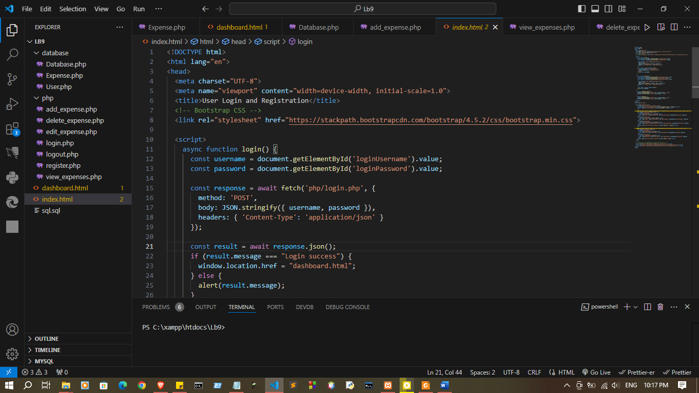
index.html
<!DOCTYPE html>
<html lang="en">
<head>
<meta charset="UTF-8">
<meta name="viewport" content="width=device-width, initial-scale=1.0">
<title>User Login and Registration</title>
<!-- Bootstrap CSS -->
<link rel="stylesheet" href="https://stackpath.bootstrapcdn.com/bootstrap/4.5.2/css/bootstrap.min.css">

<script>
async function login() {
const username = document.getElementById('loginUsername').value;
const password = document.getElementById('loginPassword').value;

const response = await fetch('php/login.php', {
method: 'POST',
body: JSON.stringify({ username, password }),
headers: { 'Content-Type': 'application/json' }
});

const result = await response.json();
if (result.message === "Login success") {
window.location.href = "dashboard.html";
} else {
alert(result.message);
}
}

async function register() {
const username = document.getElementById("registerUsername").value;
const email = document.getElementById("registerEmail").value;
const password = document.getElementById("registerPassword").value;

const response = await fetch('php/register.php', {
method: 'POST',
body: JSON.stringify({ username, email, password }),
headers: { 'Content-Type': 'application/json' }
});

const result = await response.json();
alert(result.message);
}

function showRegistration() {
document.getElementById('registration').style.display = 'block';
document.getElementById('login').style.display = 'none';
}

function showLogin() {
document.getElementById('registration').style.display = 'none';
document.getElementById('login').style.display = 'block';
}
</script>
</head>
<body class="bg-light">

<div class="container mt-5">
<div class="mb-3 d-flex justify-content-center">
<button class="mr-2 btn btn-primary" onclick="showRegistration()">Register</button>
<button class="btn btn-secondary" onclick="showLogin()">Login</button>
</div>

<div id="registration" class="p-4 shadow-sm card" style="display: none; max-width: 400px; margin: auto;">
<h2 class="text-center">Registration</h2>
<div class="form-group">
<label for="registerUsername">Username</label>
<input type="text" class="form-control" id="registerUsername" placeholder="Username" required>
</div>
<div class="form-group">
<label for="registerEmail">Email Address</label>
<input type="email" class="form-control" id="registerEmail" placeholder="Email Address" required>
</div>
<div class="form-group">
<label for="registerPassword">Password</label>
<input type="password" class="form-control" id="registerPassword" placeholder="Password" required>
</div>
<button class="btn btn-success btn-block" onclick="register()">Register</button>
</div>

<div id="login" class="p-4 shadow-sm card" style="display: block; max-width: 400px; margin: auto;">
<h2 class="text-center">Login</h2>
<div class="form-group">
<label for="loginUsername">Username</label>
<input type="text" class="form-control" id="loginUsername" placeholder="Username" required>
</div>
<div class="form-group">
<label for="loginPassword">Password</label>
<input type="password" class="form-control" id="loginPassword" placeholder="Password" required>
</div>
<button class="btn btn-primary btn-block" onclick="login()">Login</button>
</div>
</div>

<!-- Bootstrap JS and dependencies (jQuery and Popper.js) -->
<script src="https://code.jquery.com/jquery-3.5.1.slim.min.js"></script>
<script src="https://cdn.jsdelivr.net/npm/popper.js@1.16.1/dist/umd/popper.min.js"></script>
<script src="https://stackpath.bootstrapcdn.com/bootstrap/4.5.2/js/bootstrap.min.js"></script>
</body>
</html>

dashboard.html
<!DOCTYPE html>
<html lang="en">
<head>
<meta charset="UTF-8">
<meta name="viewport" content="width=device-width, initial-scale=1.0">
<title>Dashboard</title>
<link rel="stylesheet" href="https://stackpath.bootstrapcdn.com/bootstrap/4.5.2/css/bootstrap.min.css">

<script>
async function logout() {
try {
const response = await fetch('php/logout.php', {
method: 'POST',
headers: { 'Content-Type': 'application/json' }
});
const result = await response.json();
if (result.message === "Logout success!") {
window.location.href = "index.html";
} else {
alert("Error logging out. Please try again.");
}
} catch (error) {
console.error('Logout error:', error);
}
}

async function loadExpenses() {
try {
const response = await fetch('php/view_expenses.php');
const data = await response.json();
const expenseTableBody = document.getElementById('expenseTableBody');
expenseTableBody.innerHTML = '';

if (Array.isArray(data.records) && data.records.length > 0) {
data.records.forEach(expense => {
const row = document.createElement('tr');
row.innerHTML = `
<td>${expense.created_at}</td>
<td>${expense.description}</td>
<td>$${expense.amount}</td>
<td>
<button class="btn btn-primary btn-sm" onclick="showEditForm(${expense.id}, '${expense.description}', ${expense.amount})">Edit</button>
<button class="btn btn-danger btn-sm" onclick="deleteExpense(${expense.id})">Delete</button>
</td>
`;
expenseTableBody.appendChild(row);
});
} else {
const row = document.createElement('tr');
row.innerHTML = '<td colspan="4" class="text-center">No expenses found.</td>';
expenseTableBody.appendChild(row);
}
} catch (error) {
console.error('Error loading expenses:', error);
}
}

async function addExpense() {
const description = document.getElementById('description').value;
const amount = document.getElementById('amount').value;
try {
const response = await fetch('php/add_expense.php', {
method: 'POST',
body: JSON.stringify({ description, amount }),
headers: { 'Content-Type': 'application/json' }
});
const result = await response.json();
alert(result.message);
loadExpenses();
document.getElementById('addExpenseForm').reset();
} catch (error) {
console.error('Error adding expense:', error);
}
}

function showEditForm(id, description, amount) {
document.getElementById('expenseId').value = id;
document.getElementById('editDescription').value = description;
document.getElementById('editAmount').value = amount;
document.getElementById('editForm').style.display = 'block';
}

async function updateExpense() {
const id = document.getElementById('expenseId').value;
const description = document.getElementById('editDescription').value;
const amount = document.getElementById('editAmount').value;
try {
const response = await fetch('php/edit_expense.php', {
method: 'POST',
body: JSON.stringify({ id, description, amount }),
headers: { 'Content-Type': 'application/json' }
});
const result = await response.json();
alert(result.message);
document.getElementById('editForm').style.display = 'none';
loadExpenses();
} catch (error) {
console.error('Error updating expense:', error);
}
}

async function deleteExpense(id) {
try {
const response = await fetch('php/delete_expense.php', {
method: 'POST',
body: JSON.stringify({ id }),
headers: { 'Content-Type': 'application/json' }
});
const result = await response.json();
alert(result.message);
loadExpenses();
} catch (error) {
console.error('Error deleting expense:', error);
}
}
</script>
</head>
<body class="bg-light">
<div class="container mt-5">
<h1 class="text-center">Welcome to the Dashboard</h1>
<p class="lead text-center">You are now logged in.</p>
<div class="text-center mb-4">
<button class="btn btn-danger" onclick="logout()">Logout</button>
</div>

<!-- Form to add a new expense -->
<div class="mb-4">
<h4>Add New Expense</h4>
<form id="addExpenseForm" onsubmit="event.preventDefault(); addExpense();">
<div class="form-group">
<label for="description">Description</label>
<input type="text" id="description" class="form-control" placeholder="Enter description" required>
</div>
<div class="form-group">
<label for="amount">Amount</label>
<input type="number" id="amount" class="form-control" placeholder="Enter amount" required>
</div>
<button type="submit" class="btn btn-success">Add Expense</button>
</form>
</div>

<!-- Table to display expenses -->
<h4>Expense List</h4>
<table class="table table-bordered table-striped">
<thead class="thead-dark">
<tr>
<th>Date</th>
<th>Description</th>
<th>Amount</th>
<th>Actions</th>
</tr>
</thead>
<tbody id="expenseTableBody">
<!-- Expenses will be loaded here dynamically -->
</tbody>
</table>

<!-- Form to edit an expense -->
<div id="editForm" style="display: none;">
<h4>Edit Expense</h4>
<form onsubmit="event.preventDefault(); updateExpense();">
<input type="hidden" id="expenseId">
<div class="form-group">
<label for="editDescription">Description</label>
<input type="text" id="editDescription" class="form-control" required>
</div>
<div class="form-group">
<label for="editAmount">Amount</label>
<input type="number" id="editAmount" class="form-control" required>
</div>
<button type="submit" class="btn btn-primary">Update Expense</button>
<button type="button" class="btn btn-secondary" onclick="document.getElementById('editForm').style.display='none'">Cancel</button>
</form>
</div>
</div>

<script src="https://code.jquery.com/jquery-3.5.1.min.js"></script>
<script src="https://cdn.jsdelivr.net/npm/popper.js@1.16.1/dist/umd/popper.min.js"></script>
<script src="https://stackpath.bootstrapcdn.com/bootstrap/4.5.2/js/bootstrap.min.js"></script>

<script>
document.addEventListener("DOMContentLoaded", loadExpenses);
</script>
</body>
</html>

Database\
Database.php
<?php
class Database {
private $host;
private $username;
private $password;
private $database;
private $connection;

public function __construct($host, $username, $password, $database) {
$this->host = $host;
$this->username = $username;
$this->password = $password;
$this->database = $database;
$this->connect();
}

private function connect() {
$this->connection = mysqli_connect($this->host, $this->username, $this->password, $this->database);

if (mysqli_connect_errno()) {
die("Database connection failed: " . mysqli_connect_error());
}
}

public function getConnection() {
return $this->connection;
}
}
?>

Expense.php
<?php
class Expense {
private $connection;
private $amount;
private $description;
private $id;

public function __construct($connection) {
$this->connection = $connection;
}

public function setAmount($amount) {
$this->amount = $amount;
}

public function setDescription($description) {
$this->description = $description;
}

public function setId($id) {
$this->id = $id;
}

public function getAllExpenses() {
$query = "SELECT * FROM expenses";
$result = mysqli_query($this->connection, $query);

if (!$result) {
die("Failed to retrieve data: " . mysqli_error($this->connection));
}

$expenses = [];
while ($row = mysqli_fetch_assoc($result)) {
$expenses[] = $row;
}
return $expenses;
}

public function create() {
$query = "INSERT INTO expenses (amount, description) VALUES ('$this->amount', '$this->description')";
$result = mysqli_query($this->connection, $query);

return $result ? true : false;
}

public function delete() {
$query = "DELETE FROM expenses WHERE id = '$this->id'";
$result = mysqli_query($this->connection, $query);

return $result ? true : false;
}

public function update() {
$query = "UPDATE expenses SET amount = '$this->amount', description = '$this->description' WHERE id = '$this->id'";
$result = mysqli_query($this->connection, $query);

return $result ? true : false;
}
}
?>

User.php
<?php
class User {
public $username;
public $password;
public $email;
public $id;
private $conn;

public function __construct($db) {
$this->conn = $db;
}

public function setUsername($username) {
$this->username = $username;
}

public function setPassword($password) {
$this->password = $password;
}

public function setEmail($email) {
$this->email = $email;
}

public function register() {
$hash_password = password_hash($this->password, PASSWORD_DEFAULT);
$query = "INSERT INTO users (username, password, email) VALUES (?, ?, ?)";
$stmt = mysqli_prepare($this->conn, $query);
mysqli_stmt_bind_param($stmt, "sss", $this->username, $hash_password, $this->email);

$result = mysqli_stmt_execute($stmt);
mysqli_stmt_close($stmt);

return $result;
}

public function login() {
$query = "SELECT id, username, password FROM users WHERE username = ? LIMIT 1";
$stmt = mysqli_prepare($this->conn, $query);
mysqli_stmt_bind_param($stmt, "s", $this->username);
mysqli_stmt_execute($stmt);
$result = mysqli_stmt_get_result($stmt);

if ($row = mysqli_fetch_assoc($result)) {
if (password_verify($this->password, $row['password'])) {
$this->id = $row['id'];
$this->username = $row['username'];
return true;
}
}

mysqli_stmt_close($stmt);
return false;
}
}
?>

Php\
add_expense.php
<?php
require_once '../database/Expense.php';
require_once '../database/Database.php';

$database = new Database("localhost", "root", "", "expense_tracker");
$db = $database->getConnection();
$expense = new Expense($db);

$data = json_decode(file_get_contents("php://input"), true);
$expense->setDescription($data['description']);
$expense->setAmount($data['amount']);

header('Content-Type: application/json');
if ($expense->create()) {
echo json_encode(["message" => "Expense added."]);
} else {
echo json_encode(["message" => "Unable to add expense."]);
}
?>

delete_expense.php
<?php
require_once '../database/Expense.php';
require_once '../database/Database.php';
$database = new Database("localhost", "root", "", "expense_tracker");
$db = $database->getConnection();

$data = json_decode(file_get_contents("php://input"), true);
$expense = new Expense($db);
$expense->setId($data['id']);

if ($expense->delete()) {
echo json_encode(["message" => "Expense deleted."]);
} else {
echo json_encode(["message" => "Unable to delete expense."]);
}

?>

edit_expense.php
<?php
require_once '../database/Expense.php';
require_once '../database/Database.php';
$database = new Database("localhost", "root", "", "expense_tracker");
$db = $database->getConnection();

$data = json_decode(file_get_contents("php://input"), true);
$expense = new Expense($db);
$expense->setId($data['id']);
$expense->setDescription($data['description']);
$expense->setAmount($data['amount']);

if ($expense->update()) {
echo json_encode(["message" => "Expense updated."]);
} else {
echo json_encode(["message" => "Unable to update expense."]);
}

?>

login.php
<?php
session_start();
require_once '../database/Database.php';
require_once '../database/User.php';

$database = new Database("localhost", "root", "", "expense_tracker");
$db_connection = $database->getConnection();
$user = new User($db_connection);

$data = json_decode(file_get_contents("php://input"));

$user->setUsername($data->username);
$user->setPassword($data->password);

if ($user->login()) {
$_SESSION['username'] = $user->username; // Corrected here
echo json_encode(["message" => "Login success"]);
} else {
echo json_encode(["message" => "Login fail"]);
}
?>

logout.php
<?php
session_start();
$_SESSION = [];
session_destroy();
header('Content-Type: application/json');
echo json_encode(["message" => "Logout success!"]);
?>

register.php

<?php
session_start();
require_once '../database/Database.php';
require_once '../database/User.php';

$database = new Database("localhost", "root", "", "expense_tracker");
$db = $database->getConnection();
$user = new User($db);

$data = json_decode(file_get_contents("php://input"));
$user->setUsername($data->username);
$user->setPassword($data->password);
$user->setEmail($data->email);

if ($user->register()) {
echo json_encode(["message" => "User was registered."]);
} else {
echo json_encode(["message" => "Unable to register the user."]);
}
?>

view_expenses.php
<?php
require_once '../database/Expense.php';
require_once '../database/Database.php';

$database = new Database("localhost", "root", "", "expense_tracker");
$db = $database->getConnection();
$expense = new Expense($db);
$expenses = $expense->getAllExpenses();

header('Content-Type: application/json');
echo json_encode(["records" => $expenses]);
?>

Output
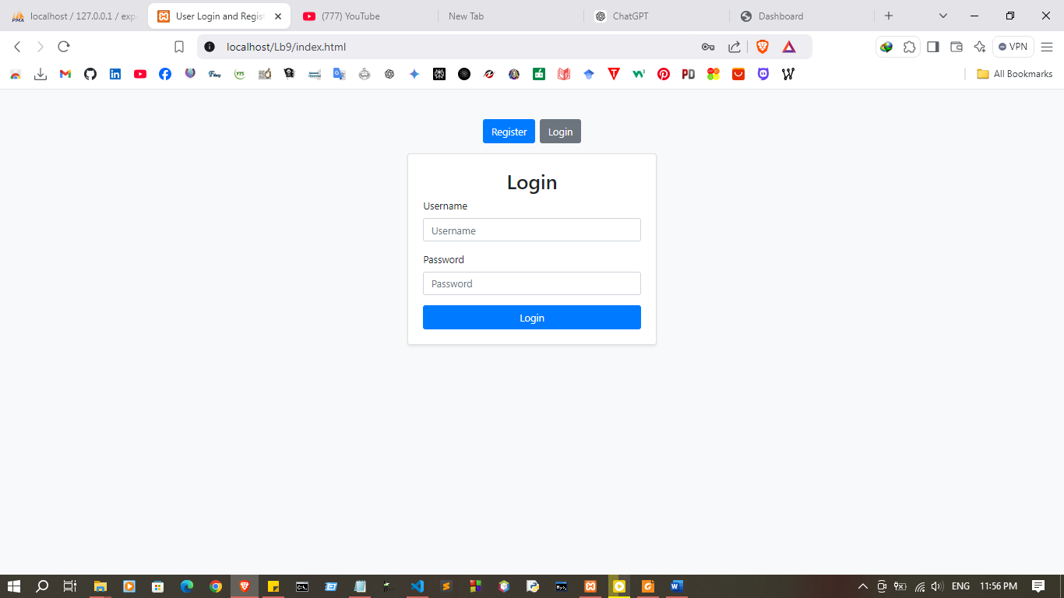

.

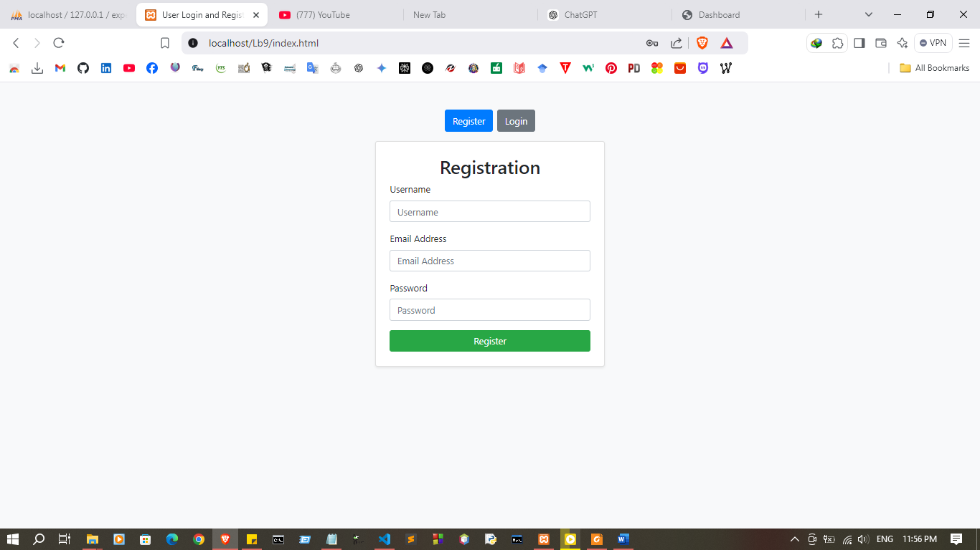
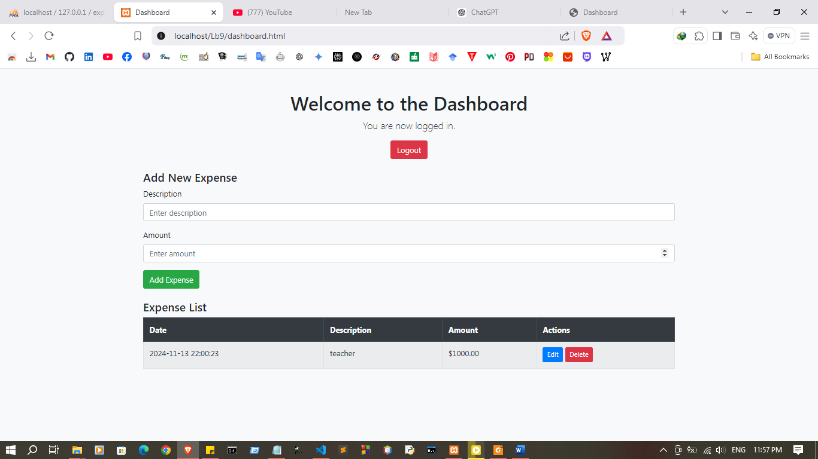
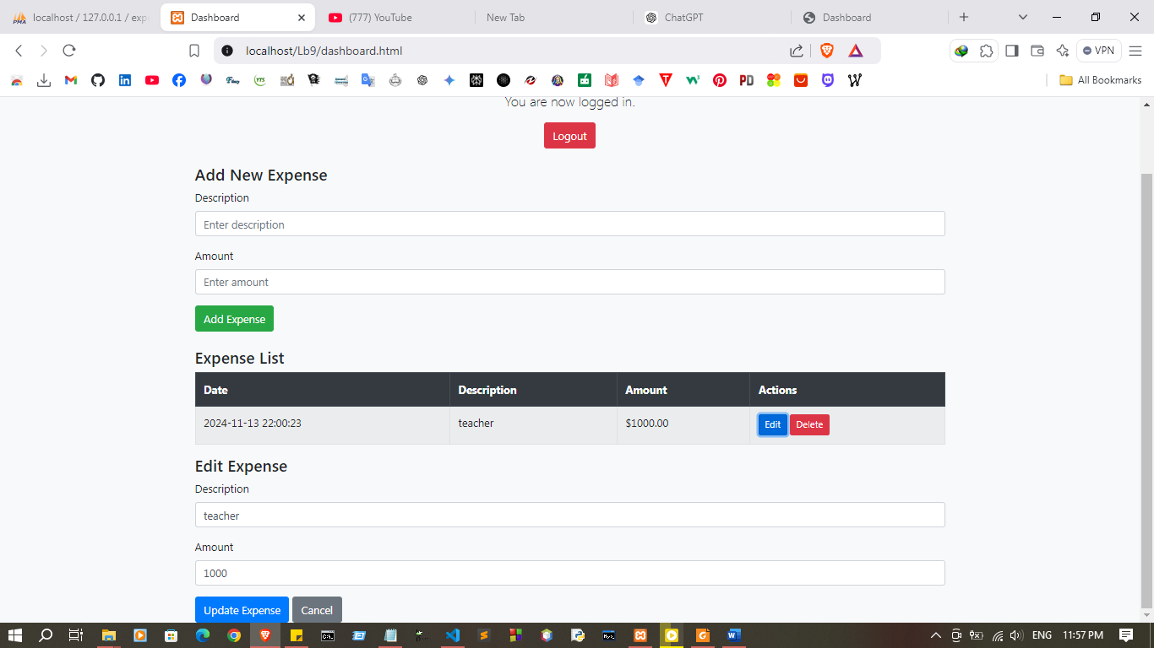
Discussion
- In this lab session, I worked on implementing CRUD (Create, Read, Update, Delete) operations using PHP and MySQL, with JavaScript on the frontend. The focus was on developing a full cycle of data management functions, where PHP acts as the server-side script to handle requests and interact with the MySQL database, while JavaScript (using the fetch() API) manages asynchronous data requests on the frontend. By using fetch(), I could send data to PHP scripts without refreshing the page, making the application more dynamic and user-friendly. This lab helped solidify my understanding of PHP as a backend language and how JavaScript can be used to improve user interactions by handling data operations seamlessly in real-time. This experience will be useful in building applications that require user interaction with databases efficiently.

